University at Buffalo Department of Orthopaedics RESEARCH NEWSLETTER

June A. and Eugene R. Mindell, MD Professor and Chair: Leslie J. Bisson, MD

Director of Clinical Research: John Leddy, MD

Director, Kenneth A Krackow Orthopedic Research Lab: Mark Ehrensberger, PhD

Editors: Allison Cornwall, MPH;; Melissa Kluczynski, MS;; Sonja Pavlesen, MD, MS

Introduction from the Director of Clinical Research

It is a pleasure to introduce the second Clinical Research News-­ letter for UBMD Orthopaedics & Sports Medicine. Clinical Re-­ search in our department involves a wide variety of orthopedic and sports medicine-related areas of investigation that are sup-­ ported by our excellent Clinical Research Associates (CRAs): Melissa Kluczynski for Sports Medicine;; Allison Cornwall for ECMC;; Sonja Pavlesen and Mary Bayers-Thering for Buffalo General Medical Center. Over the past year the CRAs have been assisting with 19 Orthopaedic resident research projects and numerous clinical research projects. Under the leadership of Dr. Ablove, 14 Medical Students were selected for the Summer Re-­ search Program, which involves attending research lectures and
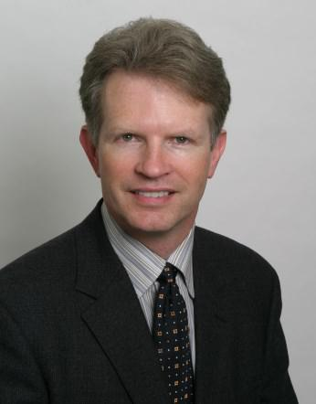
assisting with ongoing clinical research projects in our Department.

The Outcomes Based Electronic Research Database (OBERD), a program for collecting clinical outcomes and performing research, is in use and collecting electronic outcomes data throughout several offices in our Department. We continue to seek extra-­ mural sources for funding (non-profit, government, academic, and industry) and are begin-­ ning several exciting projects, including a multicenter randomized controlled trial of sub-threshold exercise treatment in adolescent sport-related concussion. We are participating in NIH-supported research with Harvard University on the TeMPO trial (Treatment of Me-­ niscal Problems in Osteoarthritis) and are awaiting word on several major grant applica-­ tions (Concussion Physiology [NIH] and Concussion Education [NCAA/DOD]). We suc-­ cessfully enrolled 3 patients for the HEALTH Study (multicenter NIH) Hip Fracture Evalua-­ tion with Alternatives of Total Hip Arthroplasty Versus Hemi-Arthroplasty. We are expand-­ ing our industry collaborations with companies such as Carestream Health, Inc. (weight bearing portable 3D cone beam CT scanner) and Trazer (virtual reality device for injury rehabilitation and concussion education). These collaborations provide opportunities for groundbreaking research and resources to support our research mission. Over the past academic year, our faculty and residents have produced an impressive 63 publications in peer-reviewed scientific journals, given 52 national and international presentations, and written 13 book chapters.

We are fortunate to have a solid foundation in clinical research to build upon. And we would like to thank our Chair, Dr. Leslie Bisson, for providing the vision and leadership to move clinical research forward, and our department for giving us the resources to help ensure that UBMD Orthopaedics & Sports Medicine will be renowned internationally for its clinical care and research, each of which informs and improves the other. Working togeth-­ er, our faculty, doctors, and research staff can take this department to the next level and fulfill that vision. On a sad note, we are sorry to see Allison Cornwall leave the department. We thank her for her excellent work over the years and we wish her all the best in her new career. Finally, our success depends upon your ideas and passion to improve clinical care through the vehicle of good clinical research, and we are here to help you as much as we can. Please do not hesitate to contact me or the CRAs with any ideas or concerns you have about clinical research at UBMD Orthopaedics & Sports Medicine.

- John J. Leddy, MD

Volume 2;; August 2015
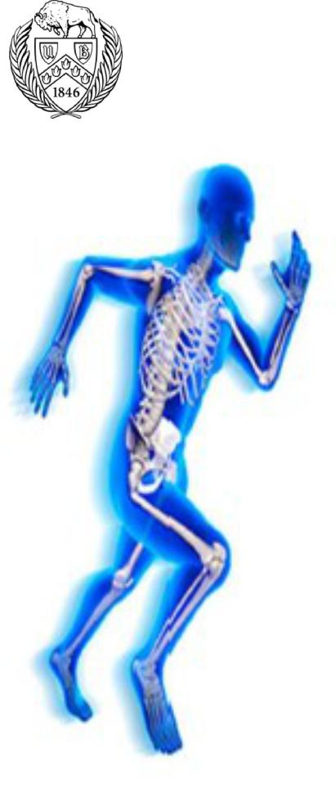

Inside this issue

Introduction……………………..1

Clinical & Basic Science………2

New Research………………….2

Announcements……………..…2

Recent Publications…….……..3

Upcoming Abstract Deadlines..3

Research Funding Sources/ Grant Deadlines…………….….4

Congratulations………………...4

Medical Student Summer Research Program…………….4

Honor Roll………………………4

IRB & Clinical Updates………..5

Epidemiology Corner………….5

Research Team Contact Info...5

UBMD Orthopaedics & Sports Medicine Clinical and Basic Science Research
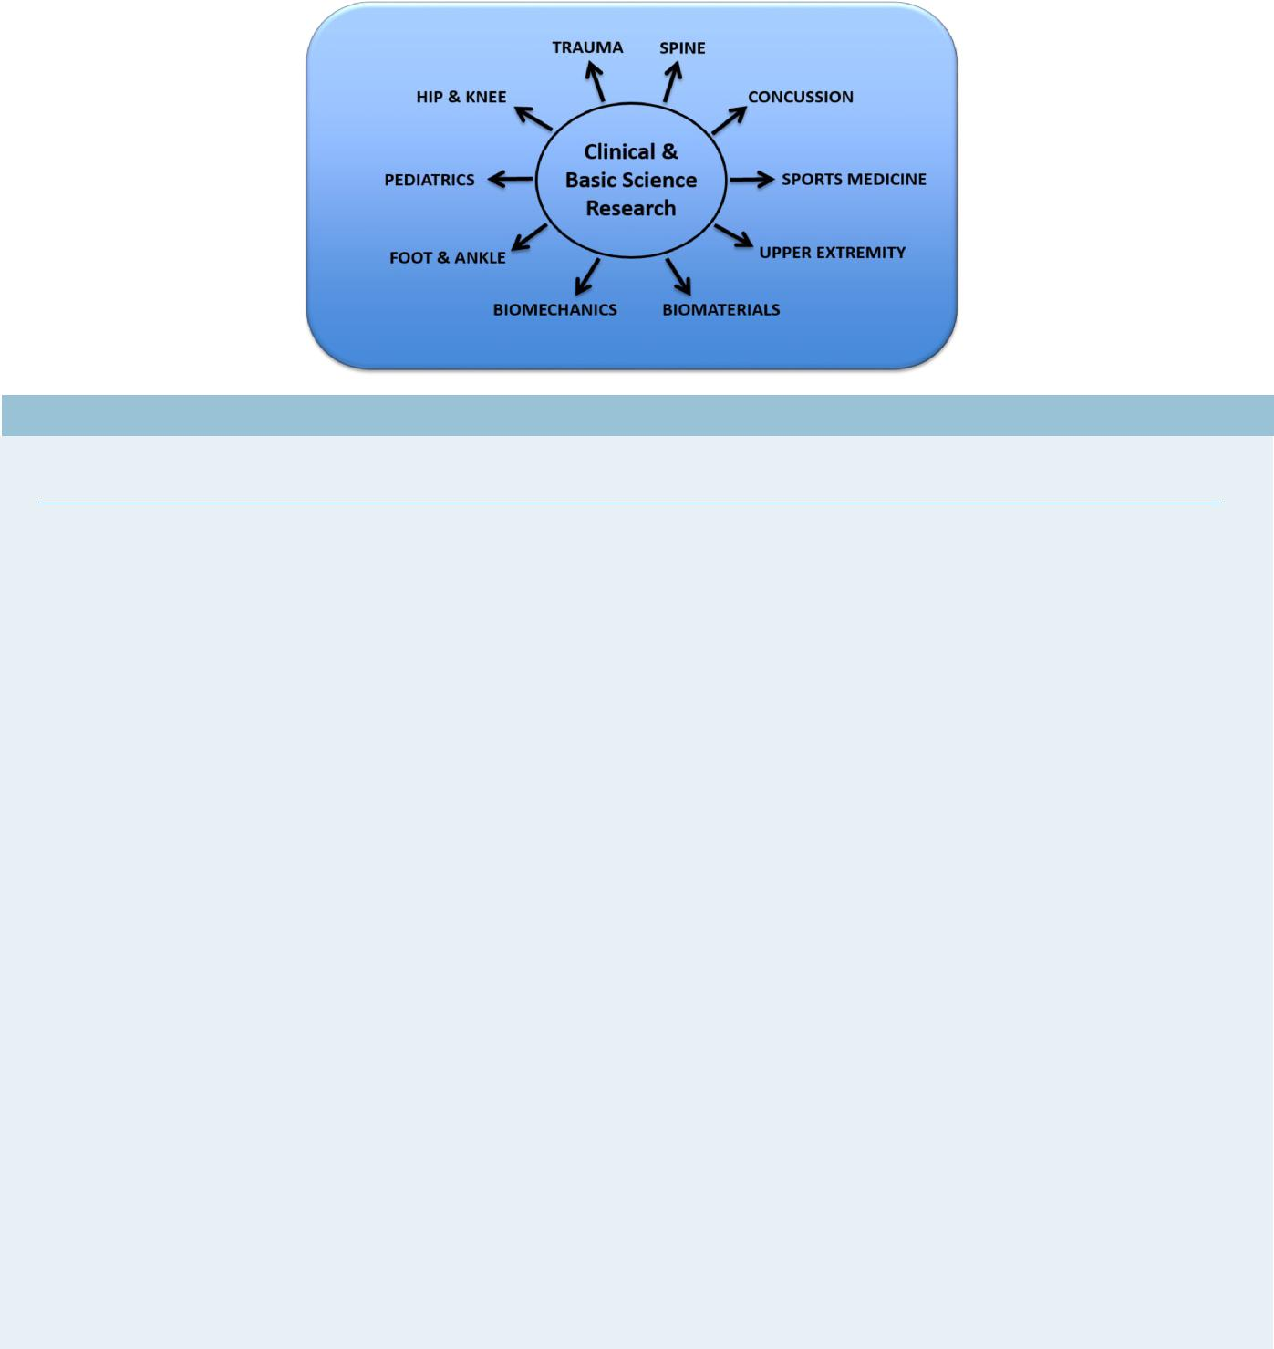

New Research Studies

Basic Science Studies

Study Title: ‘Biomechanical Stability of 3 Flexible Intramedullary Nails in Length Unstable Pediatric Femur Frac-­

tures;;’ Investigators: Ehrensberger MT, Hoy A, Doak J.;; Sponsor: Depuy Synthes

Study Title: ‘Validation of a Cone Beam CT Scanner To Measure Joint Surface Contact Area;;’ Investigators: Eh-­

rensberger MT and Marzo JM;; Sponsor: Carestream Health, Inc.

Study Title: ‘Wound Dressing Pressure Distribution;;’ Investigators: Ehrensberger MT;; Sponsor: Hollister Inc.

Study Title: ‘Portable Patient Specific Wound Healing and Bone Growth Device;;’ Investigators: Ehrensberger MT.

Sponsor: EnerMed and UB Center for Advanced Biomedical and Bioengineering Technology.

Clinical Research Studies

Study Title: ‘Clinical Evaluation of Carestream Cone Beam Computed Tomography (CBCT);;’ Investigators: Drs.

John Marzo, Anthony Notino, Gregory Shields and John Marshall Sponsor: Carestream Health, Inc.

Study Title: ‘Computed Tomography (CT) Imaging of BioComposite Interference Screw 5-years after Anterior Cruci-­

ate Ligament Reconstruction with Bone-patellar Tendon-bone Graft:’ Investigators: Drs. Marc Fineberg, Leslie Bisson and

Nick Valente;; Sponsor: Arthrex, Inc.

Study Title: ‘Medical Record Review for Treatment for Meniscal Problems in Osteoarthritis;;’ Investigators: Drs. Leslie Bisson and John Leddy. This is a pilot study for a future multi-site NIH- funded study led by Jeffrey Katz, MD at the Brigham and Women’s Hospital in Boston, MA.

Announcements

Congratulations to everyone who has given presentations or lectures thus far in 2015! The list of presentations and lectures from January to July 2015 can be found in the Appendix.-

Congratulations to the ChAMP Trial (Chondral Lesions And Meniscus Procedures;; aka ‘AD Study’) research team for completing study enrollment of 190 subjects! Subjects were recruited from the offices of Drs. Bisson (PI), Wind, Fineberg, Rauh, Bernas, and Marzo starting in January 2012 and ending in April 2015. Subject follow-up will be completed in spring of 2016.

2

Recent Publications

Peer-Reviewed Journal Articles
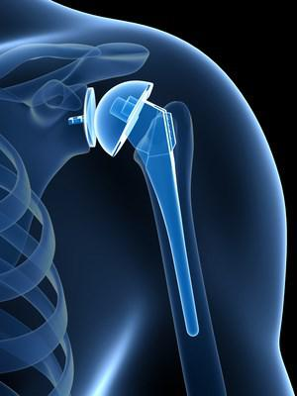

Anders, M., Mutty, C., Cornwall, A. Geographic Variation in Fasciotomy during Operative Management of Tibia Fractures. Journal of Orthopaedics. In Press.

Brooks, E.K., Tobias M.E., Yang, S., Bone, L.B., Ehrensberger, M.T. Influence of MC3T3-E1 preosteo-­ blast culture on the corrosion of a T6-treated AZ91 alloy. Journal of Biomedical Research Part B: Ap-­ plied Biomaterials, In Press.

Clausen, M., Pendergast, D.R., Willer, B., Leddy, J.J. Cerebral Blood Flow during Treadmill Exercise is a Marker of Physiological Post-Concussion Syndrome in Female Athletes. Journal of Head Trauma Rehabilitation, In Press.

Hagstrom, L.S., Ferrick, M., Galpin, R. (2015) Outcomes of operative versus nonoperative treatment of displaced pediatric clavicle fractures. Orthopedics, 38(2):135-8.

Nodzo, S.R., Hohman, D.W., Hoy, A.S., Bayers-Thering, M., Pavlesen, S., Phillips, M.J. Short Term Outcomes of a Hydroxyapatite Coated Metal Backed Patella. Journal of Arthroplasty, In Press.

Nodzo, S., Tobias, M., Hansen, L., Luke-Marshall, N.R., Cole, R., Wild, L., Campagnari, A.A., Ehrensberger, M.T. Cathodic electri-­ cal stimulation combined with vancomycin enhances treatment of methicillin-resistant Staphylococcus aureus implant-associated infections. Clinical Orthopedics and Related Research, In Press.

Book Chapters

Doak, J., Schiller, J., Eberson, C. Circulation of the Pediatric and Adolescent Hip. Roy K. Aaron (Ed.) Skeletal Circulation in Clinical Practice, WORLD SCIENTIFIC SINGAPURE, In Press.

Duquin, T.R., Nodzo, S.R. (2015). Evaluation and Treatment of the Infected Total Shoulder Arthroplasty. Sperling JW, Gamradt S, Galatz L (Eds). Let’s Discuss: Revision Shoulder Arthroplasty (ppx-x), American Academy of Orthopedic Surgeons. In Press.

Kluczynski, M.A., Bisson, L.J. ACLR Related Bone Contusions: Association with intra-articular injury, pain and outcomes. Prodro-­

mos C, Finkle S (Eds.) The Anterior Cruciate Ligament: Reconstruction and Basic Science, 2e. Elsevier. In Press.

Upcoming Abstract Deadlines for 2016 Meetings

Orthopaedic Research Society (ORS), 8/31/15

http://www.ors.org/2016annualmeeting/
Arthroscopy Association of North America (AANA), 9/8/15
http://owpm.net/abstracts/AANA/site/index/

The Pediatric Orthopaedic Society of North America (POSNA), 09/08/15
http://www.posna.org/meetings/anmeet/anmeet.asp
129th Annual Meeting of American Orthopaedic Association (AOA), 09/14/15 http://www.aoassn.org/calendar-of-events/2016-call-for-submissions.aspx

The 4th Annual Meeting of the Canadian Arthroplasty Society (CAS), 09/18/2015 http://www.coa-aco.org/cas/cas-meetings/2015-cas-meeting.html

European Society of Sports Traumatology, Knee Surgery & Arthroscopy (ESSKA) Congress, 10/10/15 http://esska-congress.org/
13th Meeting of Combined Orthopaedic Associations (COMOS), 10/15/15 http://www.comoc2016.org/call-for-abstracts
17th European Federation of National Associations of Orthopaedics and Traumatology (EFFORT), 10/30/15

https://www.efort.org/geneva2016/scientific-content/abstract-information/ American College of Sports Medicine (ACSM), 11/2/15 http://acsmannualmeeting.org/educational-highlights/call-for-abstracts-2/ American Orthopaedic Society for Sports Medicine (AOSSM), 11/3/15 https://www.sportsmed.org/Education/Faculty_Center/Abstract_and_Instructional_Course_Submissions/
World Congress on Osteoporosis, Osteoarthritis, and Musculoskeletal Diseases (WCO-IOF-EFCEO), 01/15/16 http://www.wco-iof-esceo.org/abstracts

3

Research Funding Sources/ Grant Deadlines

AOSSM Sandy Kirkley Clinical Outcome Research Grant

Funds: $20,000/yr supplemental or pilot study funding

Deadlines: 8/15/15 for pre-review and 12/1/15 for full review

http://www.sportsmed.org/Research/Research_Grants/Grants/

OTA Resident Grant Application

Funds: Resident grants are funded at the $20,000 level
Deadline: 11/9/15

http://ota.org/research/research-studies/

ASES 2016 Research Grant Application

Funds: Grants will be funded up to $20,000

Deadline: 9/10/15

http://www.ases-assn.org/?p=physic-grants

OREF Grants

Funds: Musculoskeletal Transplant Foundation (MTF), $98,000 grant ($49,000/yr)

OREF/Goldberg Arthritis Research Grant, $50,000 start-up funding
OREF/ASES/Rockwood Clinical Research Grant in Shoulder Care, $50,000
Deadline: 9/2/15

http://www.oref.org/grants-and-awards/grant-programs/research-specific-grants

University at Buffalo IMPACT (Innovative Micro-Programs Accelerating Collaboration in Themes) Funding Funds: Requests up to $35,000 for projects lasting 1-year or less

Deadline: 11/2/15

http://www.buffalo.edu/research/research-services/find-funding/find-ub-funding/impact-funding.html
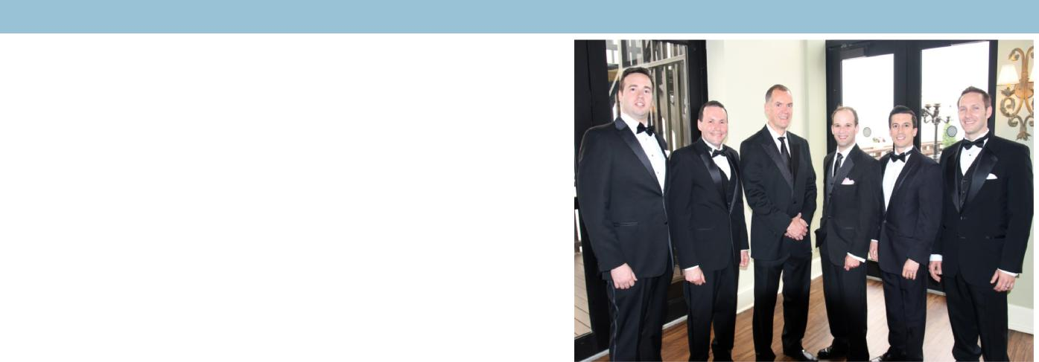

Congratulations to our graduates!

We would like to dedicate the 2nd issue of the Research Newsletter to our 2015 orthopaedic residency graduates, Drs. Scott R. Nodzo, Evgeny Dyskin, Joseph Kuechle, Karl Seth Kuwik, and Mike Miladore. Here is a sampling of their most recent research achievements:

Dyskin, E., Ferrick, M. (2015) Semirigid Abduction Bracing is Effective Treatment of Reducible Developmental Dysplastic Hips after Failure of Pavlik Harness. Annals of Orthopaedics and Rheumatology, 3(2):
1045.

Miladore, M.P., Nodzo, S.R., Rohrbacher, B., Ritter, C.A. Early Postop-­ erative Outcomes of Different Bone Graft Harvesting Techniques for Tibiotalar Arthrodesis. American Academy of Orthopedic Surgeons Annual Meeting. Las Vegas, Nevada. March 2015. Poster Presenta-­ tion.

Nodzo, S.R., Tobias, M., Hansen, L., Luke-Marshall N., Ahn R., Campagnary A., Ehrensberger, M.T.. Electric Stimulation Com-­ bined with Antibiotics Treats Periprosthetic Joint Infection. Eugene R. Mindell, M.D. 9th Annual Orthopaedic Residency Scientific Program, 9th Annual Eugene R. Mindell, M.D. Orthopaedic Residency Scientific Program - Best Research Presentation

2015 Medical Student Summer Research Program

This summer concludes our second year of an organized summer research program for medical students between their 1st and 2nd year. Led by Dr. Ablove, interested students were matched with a faculty mentor to gain research experience & clinical/OR obser-­ vation hours during the summer. Students attended 10 weekly research workshops on topics ranging from “Forming a hypothesis” to “Poster presentation preparation.” Fourteen medical students researched with our department this summer—thank you to all staff and faculty who have worked with the students to help make this program a success.

Honor Roll

We’d like to acknowledge the following faculty for their great effort in mentoring medical student and resident research in our de-­ partment throughout the year: Drs. Ablove, Anders, Bisson, Bernas, Doak, Duquin, Ehrensberger, Ferrick, Fineberg, Kowalski, Krackow, Marzo, McGrath , Mutty, Phillips, Rachala and Stegemann .

4

IRB and Clinical Research Office Updates

The University at Buffalo Office of Vice President Research has informed us that they have purchased two new tools to better support research activities and compliance: Click, a grants management system which contains pre-award, post-award and com-­ pliance functions (including modules for IRB, financial conflicts of interest, IACUC, and safety committees);; and OnCore, a clinical trials management system (CTMS), which will allow for enhanced trial management, robust reporting, enrollment tracking and accurate clinical research billing. This initial implementation will occur in various business and administrative offices, with imple-­ mentation being rolled out to users starting as early as October 2015, and continuing into 2016.

Additionally, all studies will now need to be submitted to the Clinical Research Office (CRO) for approval prior to IRB submission. This process is intended to help the CRO facilitate and support our research by: assisting us with conducting feasibility assess-­ ment, develop/negotiate favorable budget terms and contract terms to protect the University and PI, provide for billing compliance, and assist with grant development/writing/review. Please see a department research associate in the planning stages of a new project, and they will help you navigate these new changes.

Epidemiology Corner

What is Reliability and Validity?

RELIABILITY:

Definition: The degree of stability exhibited when a measurement is repeated under identical conditions. Common types include intra-rater (within the same rater), inter-rater (between multiple raters) and intra-individual (within the same individual).

Some common statistical tests for measuring reliability: Kappa statistic, percent agreement, coefficient of variation

VALIDITY:

Definition: Relative absence of BIAS or systematic error. For clinical studies, it is the ability of a novel test to identify a person who does or does not have a specific disease (or condition) of interest in comparison to the gold standard test. Common types include 1.) Internal Validity (the degree to which a test or instrument measures what it sets out to measure) and 2.) External Valid-­ ity (the degree to which findings of a test or instrument apply to individuals outside of the population from which they originated- i.e., generalizability). Some common statistical tests for measuring validity: sensitivity and specificity

*Reference: A Dictionary of Epidemiology, 5th edition, M.Porta http://www.oxfordreference.com/view/10.1093/acref/9780195314496.001.0001/acref-9780195314496

Research Team Contact Information

Clinical Research

John Leddy, MD leddy@buffalo.edu

Director of Clinical Research

Buffalo General Hospital

Sonja Pavlesen, MD, MS pavlesen@buffalo.edu Clinical Research Associate

Mary Bayers-Thering, MS, MBA

MBayers-Thering@KaleidaHealth.Org
Research Coordinator, Coordinator for Surgical Skills Training

Laura Ryan, MPH laurabec@buffalo.edu Clinical Research Assistant

Sports Medicine/Harlem Rd. office

Melissa Kluczynski, MS mk67@buffalo.edu Clinical Research Associate

Basic Sciences

Kenneth A. Krackow Orthopaedic Research Lab, Farber Hall

Mark Ehrensberger, PhD mte@buffalo.edu

Director

Menachem Tobias, MS metobias@buffalo.edu Research Scientist

Craig Howard, BS cshoward@buffalo.edu

Research Scientist

Jenna Ferrentino jferrent@buffalo.edu

Staff Assistant

Biostatistics

Terry Mashtare, PhD tlm24@buffalo.edu

Please send research news items for future issues of this newsletter to any of the CRAs.
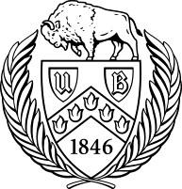

University at Buffalo Department of Orthopaedics Research Newsletter

5

